Studio in Photography
Mr. Martin

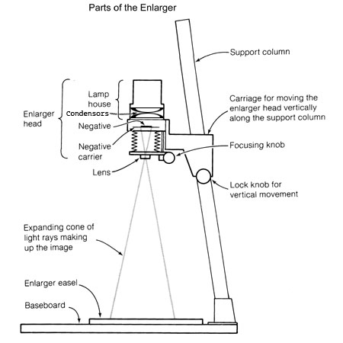

MAKING A CONTACT SHEET

- Raise the enlarger head to its highest height.
- Close down the aperture on the enlarger lens to the second dullest setting.
- MAKING SURE NO PHOTO PAPER IS OUT. Set the enlarger timer switch to focus and place the contact glass within the area of the projected light. Set the enlarger timer back to timer and set to 20 seconds.
- Place your negative sheet, emulsion side down (so the numbers are true facing up), on top of a piece of photographic paper with the emulsion side facing up underneath the contact glass. EMULSION TO EMULSION.
- Push the timer button and expose the paper.
- Develop the paper as usual (Developer, stop, fix and water. Hang dry print completely before putting it in your folder).

MAKING A PRINT

- Place negatives in negatives carrier, emulsion side down and upside down,
- Check that the negative is within the frame of the negative carrier and dust-free.
- Place the negative carrier into the enlarger, turn the light on by flipping the focus switch on the enlarger timer and make sure the enlarger head is flush and square on the negative carrier.
- ADJUST HEIGHT TO MAKE IMAGE THE SIZE OF DESIRED PHOTOGRAPH.
- Using micro focus, focus image; turn off light. (Focus on the brightest aperture setting, expose on the dullest).
- Make a test strip in the most important section of the print, emulsion side up.
- Set the timer to 5 seconds and the lens aperture to f 16.
- Cover the majority of the test strip with a piece of black mat board and press the timer button to expose the paper for 5 seconds.
- Carefully move the mat board, without moving the photo paper, to reveal more of the test strip. Press the timer button to expose the paper for another 5 seconds. Repeat this 5-8 times.
- Develop test strip as usual (90 seconds in the developer, 30 seconds in the stop and fix test strips for one minute before looking at them under natural light).
- WITH TONGS, place the test strip in a tray and bring outside to look at the results in natural light.
- Using the best time indicated on the test strip, expose another test strip with making a scale, develop and check.
- If the time of the second test print looks good, make a final print for the same time. DO NOT BRING OUT THE FINAL PRINT… Leave it in the fixer for the entire time and final wash.

***THIS PROCESS HAS TO BE REPEATED EACH TIME YOU PRINT A NEW PHOTOGRAPH***

