Molecular Models absent Make-up
Directions: The two images below are completed molecular models of the structural formula for each of the different molecular models in the ”Molecular Models” lab. Look at the structure of each model and determine which compound/molecule is shown. Then based on the composition of the compound determine if it is organic or inorganic. Draw the structure of the compounds shown.
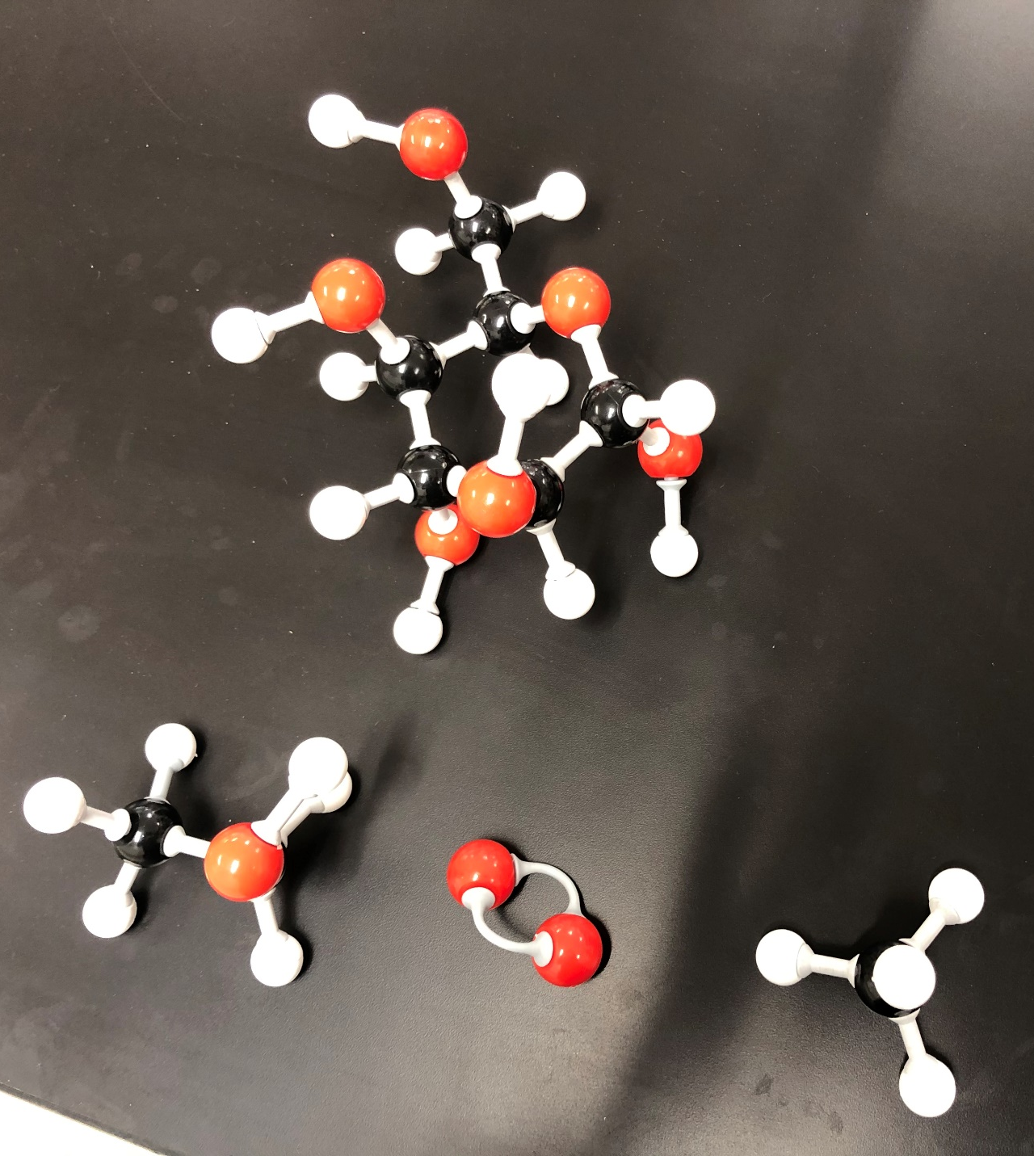
Complete the facts by looking up or using your brains, a combination is preferred though…
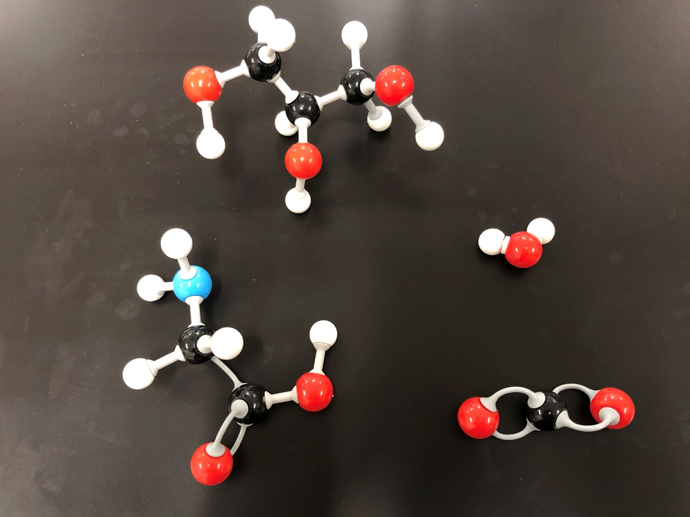
Picture 1. The Chemical Formulas
**Note: There is a Carbon here, bonded to the Oxygen

