Name:________________ Date:____________
Polymers, Dehydration Synthesis
and Hydrolysis Notes
How Do we build them up and how do we break them down? BUT FIRST….
BY THEM we mean compounds and/or molecules remember molecules make up compounds

What is a polymer- ____________________________________________________

___________
What are the sub-units of a choo-choo train?

A single car = a sub-unit or _____________

Two sub-units = dimer

3 sub-units or more =________

Polymer Monomer (building blocks)
Complex carbohydrates aka _________________ ------------- simple sugars ie __________
Lipids (fats, Waxes and oils) not true polymers but quite large ---- ______ and ___________
Proteins aka _______________ ----------------------------------------- ___________________
Nucleic Acids (DNA & RNA) aka _______________ -------------- _________________

Now how do we build them and how do we break them
Dehydration synthesis “dehydration = “synthesis” =

Hydrolysis “Hydro = “lysis”=

Process | Starts with | Ends With | Example
Dehydration Synthesis | Small molecules (sub-units) | Larger molecules & water | Growth
Hydrolysis | Water and large molecules | Small molecules (sub-units) | Digestion
Examples
Starts with | Ends With
(Dehydration synthesis)  Glucose + glucose (needs energy)  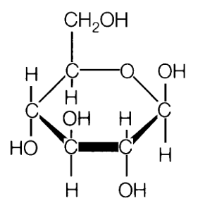 | (Dehydration synthesis)  Maltose and water  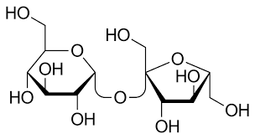
(Hydrolysis)  maltose and water | (Hydrolysis)  Glucose + glucose

