Name: _______________ Date:________________
Chapter 28
Section 28-4 The origins of Life- Early Hypotheses
28-5 The Origins of life- Modern Hypotheses

The idea of spontaneous generation: (abiogenesis)

Egyptians, Greeks and the active principle:
Believed the air contained a _________ ___________.

Helmont and the 1600’s supports spontaneous generation

+ + =

Redi in the mid 1600’s opposes spontaneous generation!!
Describe his experiment below (discuss first with neighbor… Write/diagram at the end)

Leeuwenhoek in the 1700’s and microorganisms: Support or refute spontaneous generation
Invented the ________________. Looked at microbes in a drop of water for the first time. The water was “sterile” but in reality was mixed with __________.

Needham in 1745: support or reject spontaneous generation
He attempted to boil a ___________ bottle of gravy. The _________ he proposed would kill all life. Several days later he found life in the sealed container which he claimed came from the gravy.

Flaw:
Spallazani in 1765: support or reject spontaneous generation
- Challenges Needham, boiled __ _________, one is covered the other is not.
Life is found in both containers.

Flaw:

Pasteaur to the rescue in 1860!!!!! Draw his set up… and label

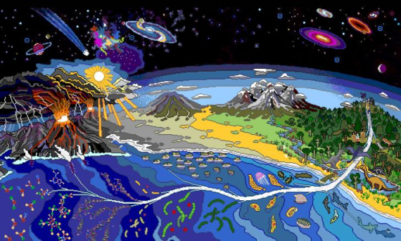
The origins of Life Modern Hypothesis chapter 28-5

Biogenesis:

Oparin’s Hypothesis or The Heterotroph Hypothesis in the 1920’s and 1930’s

Heterotroph Hypothesis:

About ___ Billion years ago Primitive earth conditions:
Chemicals Natural phenomenon Lacked
- - -
- -
- -
- -
-

*Not present or much lower amount in modern earth
**Present in modern earth
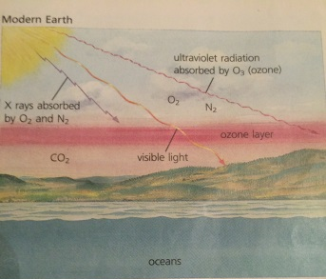
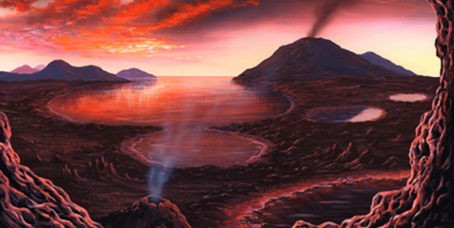

Draw the conditions of primitive earth
PRIMAL EARTH Modern Earth

Inorganic organic molecules
Overarching concept – Heat and other ___________ sources needed to ________ and form ____________ bonds.
Energy sources in primordial earth:
  - ___________ elements in earth crust
  - Electrical energy _________________ ****
  - __________ and ultroviolet radiation
**** used in Miller’s experiment
Miller’s hypothesis in 1953 and the experiment at the University of Chicago.
- Simulates the formation of ________ compounds from the _________ found on primitive earth. (gases= methane CH4, Ammonia NH3, Water H2O, and Hydrogen H2)

_________ for organic molecules include combination of ____________

Also need a source of energy heat or a spark ________________

Fill in the setup below:

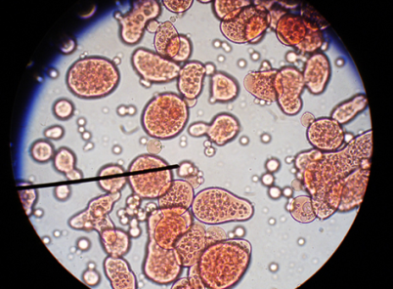
Coacervates (the first heterotroph)
circle WERE THEY AEROBIC OR ANEROBIC?
- Found in the ________ _________ of oceans
- Form clusters of large _____________ molecules (amino acids, sugars, proteins, nucleotides)

- Water molecules form a ___________ or bubble like membrane ___________ contents can be chemically different from ____________ environment.
Stable internal environment = ___________________
Leads to build up of C02 in the atmosphere

First autotrophs (first photosynthetic organisms)
Equation for photosynthesis and circle what is gas is produced by photosynthesis

Leads to aerobic respiration uses ______ and produces _______

Aerobic respiration and autotrophic organisms lead to a _______________ in the amount of ______ and ________ in the atmosphere.

Development of an Atmosphere

Lightning = converts _____ in atmosphere into ________ (ozone)
Ozone atmosphere

What does an atmosphere do for us organisms?

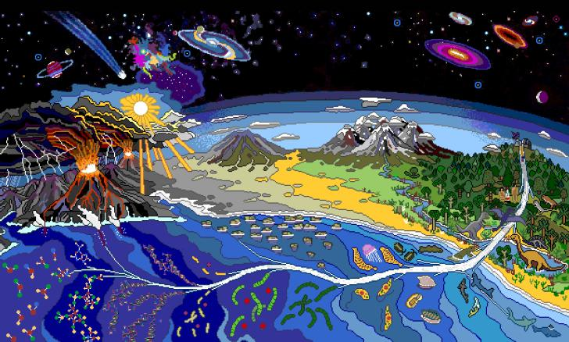

Name: __________________ Date:_______________

Use pages 585-593 and your notes to answer the questions below. Make sure to number the responses.

28-4 Early Hypothesis
- What is spontaneous generation?

- What did Leeuwenhoek discover?

- Why did Pasteur alter the shape of his flasks in his experiment with spontaneous generation?

28-5 Modern Hypothesis
- What is biogenesis?

- What is the name of Oparin’s hypothesis of the origin of life?

- Name the components of the atmosphere thought to have been present on the primitive earth. What important photosynthesis product was missing?

- What are the steps to how life was formed? (ie autotrophs, anaerobic and aerobic heterotrophs)

